**Version Control System**

* Version Control System (VCS) / Source Code Management (SCM) is a tool that helps to store files and track the changes happening to files.
* VCS also preserve older and later versions of the code so that at any time we can switch between whichever version we want.
* VCS also keep a track of who is making what kind of changes
* Types of VCS
  + Centralized VCS
  + Distributed VCS

**Centralized VCS**

* In centralized VCS, A central repo is maintained where all the versioned files are kept.
* Developers can check-in and check-out changes from their own computers.
* Example:
  + SVN

**Disadvantages of Centralized VCS**

* In case of central server failure whole system goes down.

**Distributed VCS**

* We have a local repository on every team members machines where version controlling happens at the level of individual team members form where it is uploaded into a remote server where version controlling happens for the entire team.
* Developer’s will perform PUSH and PULL operation.
* Example:
  + Git

**Setting up git on Windows**

1. Download git from

<https://git-scm.com/downloads>

1. Install it
2. Open Git Bash and Execute the git commands

**Git Life Cycle Phases / Workflow**

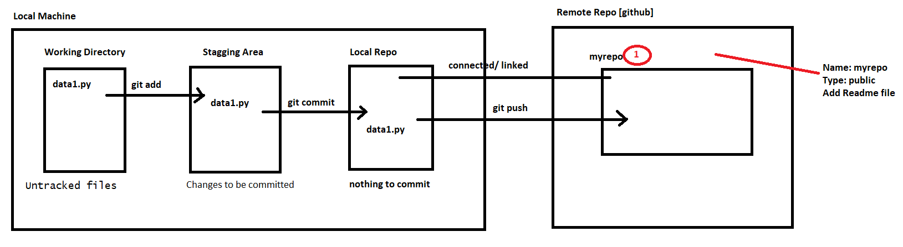

**Create Remote Repo**

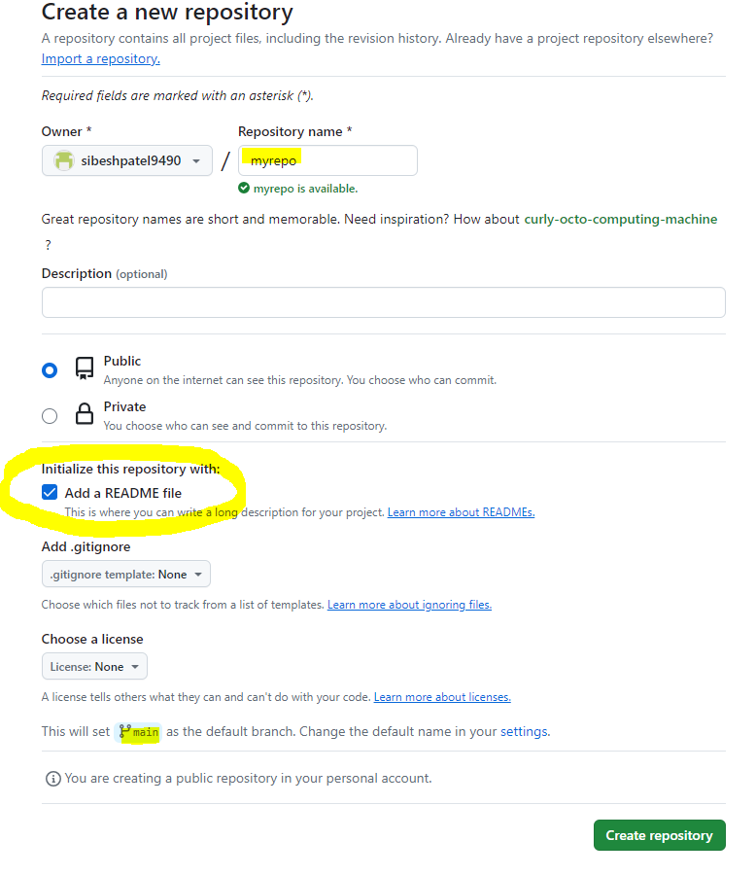

* Repository Name: my-repo
* Type: Public
* Add Read me file [enabled]

**Local Machine**

**Configuring User Name and Email**

git config --global user.name "Sibesh Patel"

git config --global user.email "sibeshpatel9490@gmail.com"

**Create Repo**

Step1:

* Initialize git repository

git init

* Pull code from remote repo

git pull git-repo-url

Step2:

* Create few files

data1.txt

* Check Status

git status

Step3:

* Move files from working directory to staging area

git add .

Step4:

* Move files from staging area to local repo

git commit -m 'data1.txt added'

Step5:

* Link with remote repo

git remote add origin <git-repo-url>

git branch -M main

Step6:

* Push Code to Remote Repo

git push -u origin main

* It will ask for authentication.

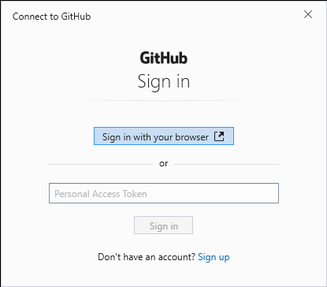

Click on sign-in with browser and login to GitHub for authentication.